14.16: a) Gauge pressure is the excess pressure above atmospheric pressure. The pressure difference between the surface of the water and the bottom is due to the weight of the water and is still 2500 Pa after the pressure increase above the surface. But the surface pressure increase is also transmitted to the fluid, making the total difference from atmospheric 2500 Pa+1500 Pa = 4000 Pa.
b) The pressure due to the water alone is 2500 Pa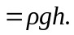 Thus

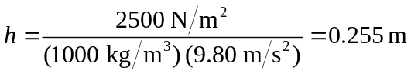

To keep the bottom gauge pressure at 2500 Pa after the 1500 Pa increase at the surface, the pressure due to the water’s weight must be reduced to 1000 Pa:
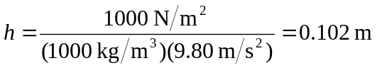

Thus the water must be lowered by 